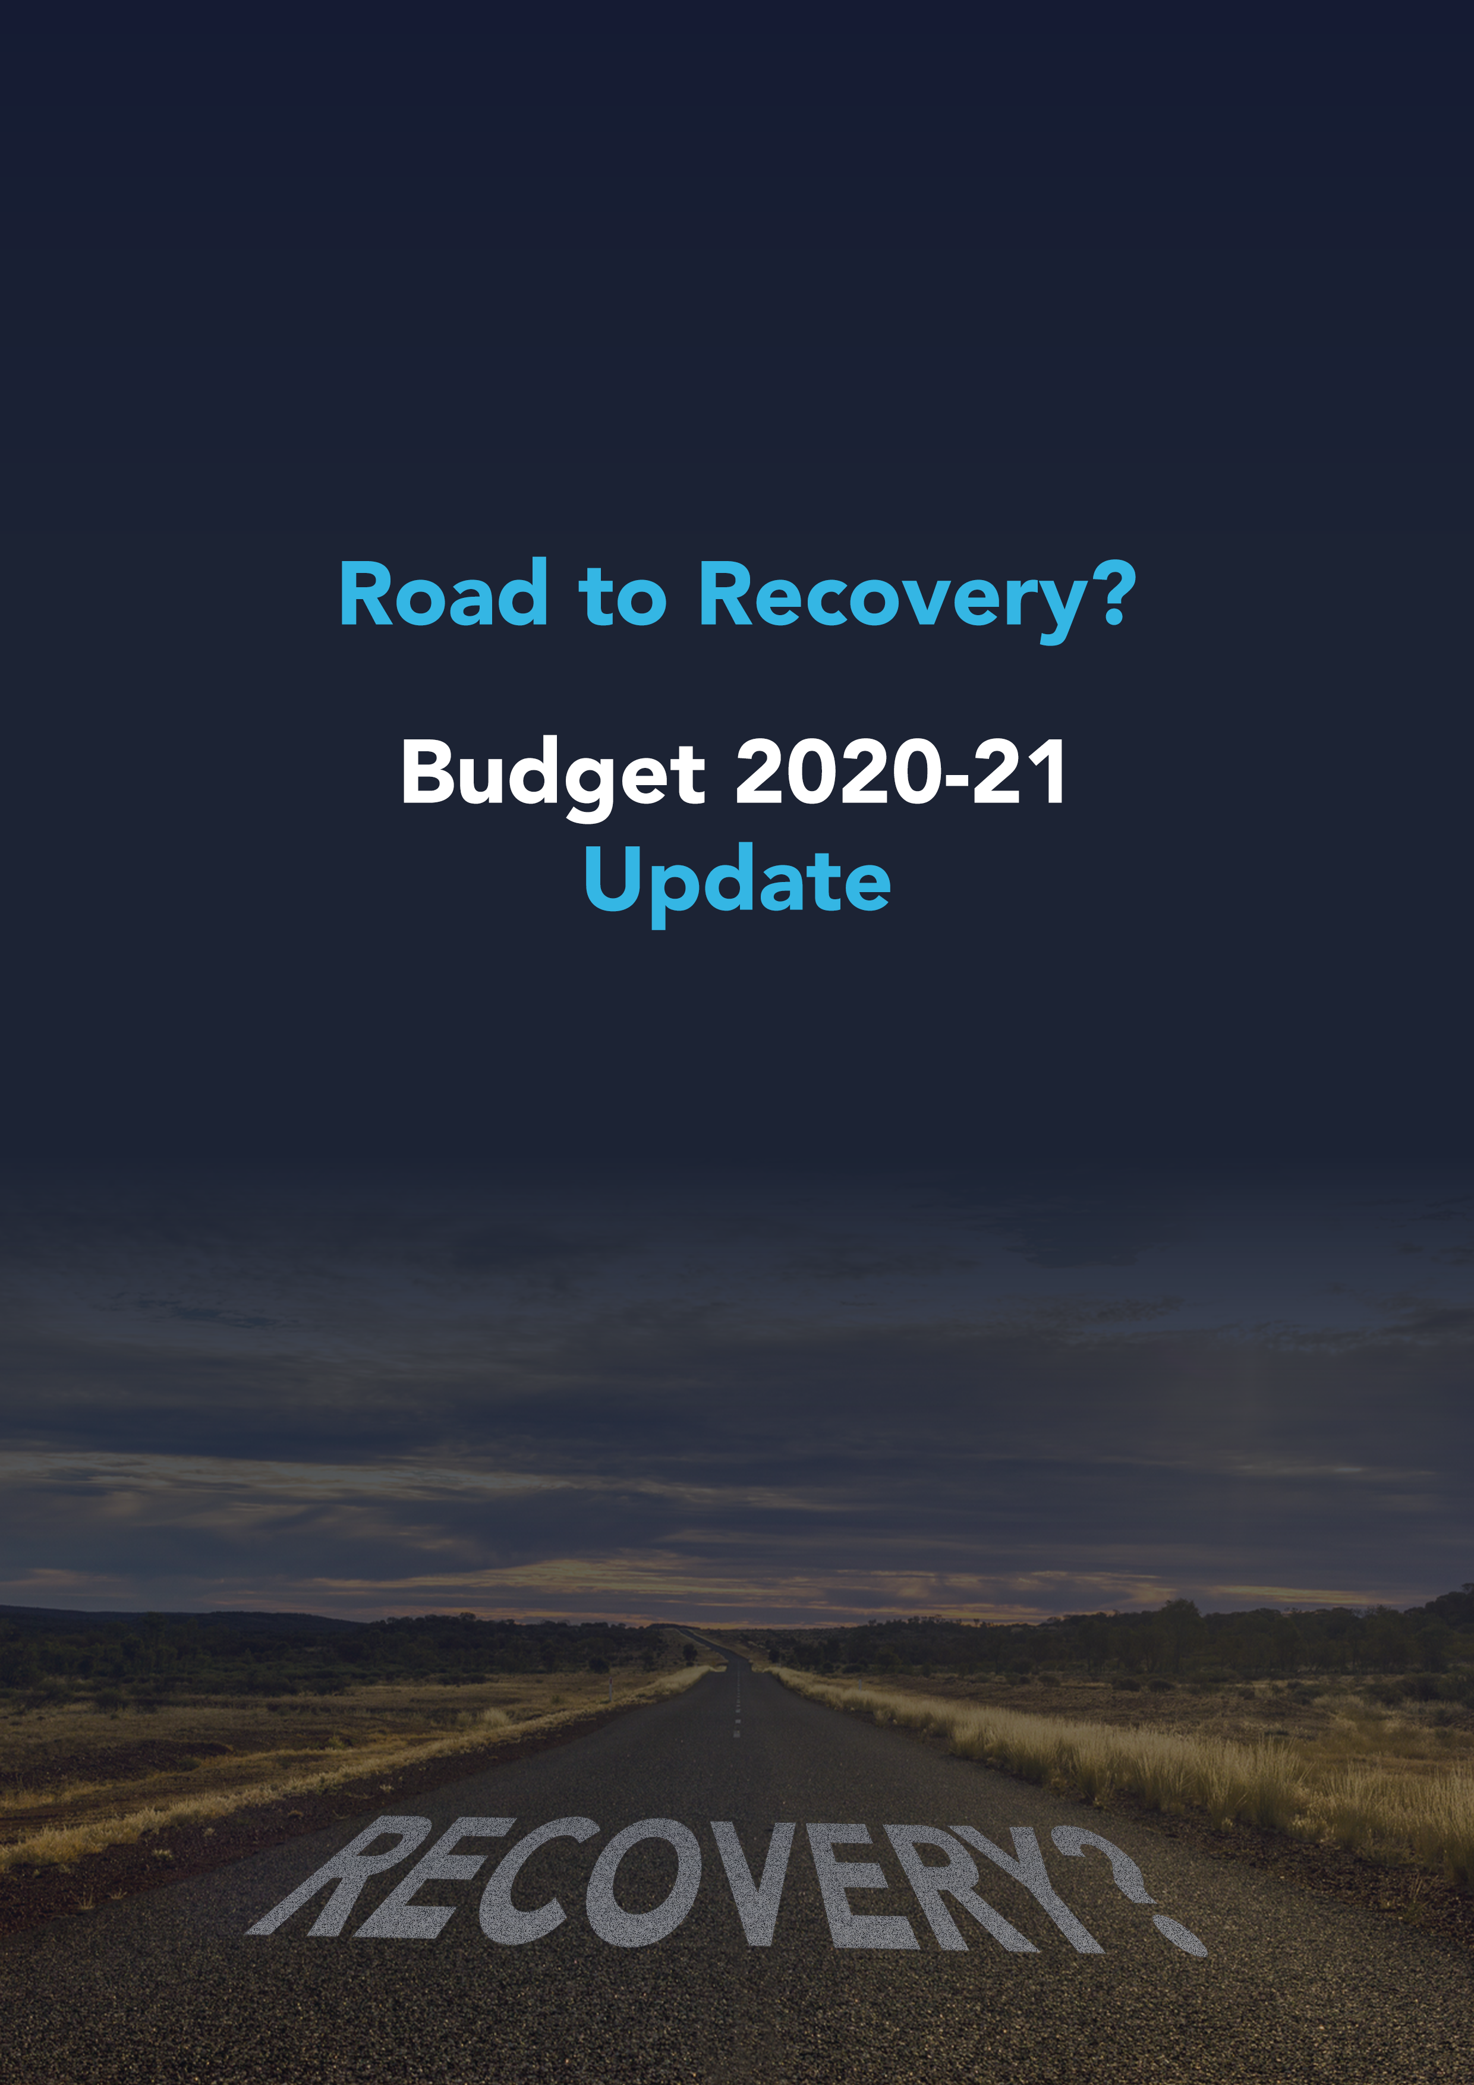

Contents
Road to Recovery? 4
For You 5
Personal income tax cuts 5
$250 economic support payments 6
Capital gains tax removed from ‘granny flats’ 6
10,000 additional places in First Home Loan Deposit Scheme 7
Aged care support 7
$1.6bn to help elderly stay at home 7
Aged care industry monitoring and support 7
Your Superannuation 8
Superannuation accounts ‘stapled’ to an individual 8
Accountability of underperforming funds 8
Performance transparency 9
Trustee accountability 9
Business & Employers 10
JobMaker Hiring Credit 10
Immediate deductions for investment in capital assets 10
Second-hand assets 10
Small business pooling 11
Ability for companies to carry-back losses 11
R&D tax concessions injection and simplification 12
Companies under $20m turnover 12
Companies over $20m turnover 12
Access to tax concessions extended to businesses up to $50m 13
FBT exemption for retraining and reskilling workers 14
Corporate residency test changes 14
FBT record keeping simplified 15
Managed investment trust withholding rate standardised across international information sharing agreements 15
Victorian business support grants to be tax-free 16
100,000 new apprenticeships 16
Specific regional COVID-19 funding measures 16
Infrastructure 18
Water infrastructure 18
$7.5bn transport infrastructure injection 18
Australian Capital Territory 18
New South Wales 18
Northern Territory 18
Queensland 19
South Australia 19
Tasmania 19
Victoria 19
Western Australia 20
Road and safety upgrades 20
$150m for indigenous home ownership program 20
Other 21
$1bn university research package 21
Modern manufacturing 21
$1.9bn for new energy technology 21
Strengthening the Defence industry 22
Enhancing regional programs 22
Women’s economic security 22
Streamlining the agricultural export process 22
Support for drought affected farmers and communities 23
Import duty waived on medical and hygiene products 23
2020-21 migration 23
Business innovation and investment 23
Temporary visa holders working in key sectors 24
Agriculture 24
Supermarkets, aged and disability care 24
Updated list of deductible gift recipients 24
Clarification of income tax exemption of workers with international organisations 25
The Regulators 25
The Economy 26

The information contained herein is provided on the understanding that it neither represents nor is intended to be advice or that the authors or distributor is engaged in rendering legal or professional advice. Whilst every care has been taken in its preparation no person should act specifically on the basis of the material contained herein. If assistance is required, professional advice should be obtained.

The material contained in the 2020-21 Budget Update should be used as a guide in conjunction with professional expertise and judgement. All responsibility for applications of the 2020-21 Budget Update and for the direct or indirect consequences of decisions based on the 2020-21 Budget Update rests with the user. Knowledge Shop Pty Ltd, firm name directors and authors or any other person involved in the preparation and distribution of this guide, expressly disclaim all and any contractual, tortious or other form of liability to any person in respect of the 2020-21 Budget Update and any consequences arising from its use by any person in reliance upon the whole or any part of the contents of this guide.

Copyright © Knowledge Shop Pty Ltd. 7 October 2020

All rights reserved. No part of the 2020-21 Budget Update should be reproduced or utilised in any form or by any means, electronic or mechanical, including photocopying, recording or by information storage or retrieval system, other than specified without written permission from Knowledge Shop Pty Ltd.

Road to Recovery?
The 2020-21 Federal Budget is a road to recovery paved with cash.

Key initiatives include:
- Personal income tax cuts from 1 July 2020
- A $4 billion ‘JobMaker’ Hiring Credit to encourage businesses to take on additional employees aged 16 to 35 years old
- $110 billion in infrastructure investment over 10 years
- Immediate deductions for business investment in capital assets
- Changes to how companies can manage losses
- Access to generous tax concessions for a wider range of businesses

The Budget also contains two additional Economic Support payments to pensioners and other eligible recipients to drive money back into the economy.

By comparison to many, Australia has managed the COVID-19 pandemic well, but good management isn’t enough to protect us from the $213.7 billion deficit in 2020-21. The Government has taken to heart the old adage, “You have to spend money to make money” to trade our way out of a black hole.

Some of the measures are aimed at addressing the harsh lessons COVID-19 has taught us and seek to centralise production back in Australia to ensure our industries can be self-reliant.

Outside of the big ticket tax measures, what is striking about this Budget is the sheer volume of initiatives it funds - too many to itemise in this update. Many of the initiatives aim to improve how Government interacts with the community and business in particular. This funding is focussed on streamlining interaction and compliance with Government requirements and investing in the IT infrastructure required to digitise the compliance process.

The final comments in the Treasurer’s Budget speech paint a cautionary tale. The focus right now is on the path to growth and stabilising debt in an effort to boost consumer and business confidence. However, once “recovery has taken hold and the unemployment rate is on a clear path back to pre-crisis levels” of below 6%, the second phase will kick in - the deliberate shift from providing temporary and targeted support to stabilising debt.

Firm name
Contact details

For You

Personal income tax cuts
Date of effect | 1 July 2020

As widely predicted, the Government has brought forward stage 2 of its planned income tax cuts by two years. Originally intended to apply from 1 July 2022, the tax cuts will come into effect from 1 July 2020 (subject to the passage of the legislation).
More than 11 million taxpayers will get a tax cut backdated to 1 July this year.”
Treasurer the Hon Josh Frydenberg, Budget Speech 2020-21

At a cost of $17.8 billion over the forward estimates, bringing forward the tax cuts is a controversial move. The Government argues that the measure will “boost GDP by around $3.5 billion in 2020-21 and $9 billion in 2021-22 and will create an additional 50,000 jobs by the end of 2021-22.” Others in Parliament believe the measure rewards higher income earners and the money could be better spent elsewhere. The Senate will decide whether the Government’s plan comes to fruition.

Stage 3 of the Personal Income Tax Plan that simplifies and flattens the personal income system remains scheduled for 2024-25.

 | Tax thresholds
Tax rate | Current | From 1 July 2020 | From 1 July 2024
0% | $0 - $18,200 | $0 - $18,200 | $0 - $18,200
19% | $18,201 - $37,000 | $18,201 - $45,000 | $18,201 - $45,000
30% |  |  | $45,001 - $200,000
32.5% | $37,001 - $90,000 | $45,001 - $120,000
37% | $90,001 - $180,000 | $120,001 - $180,000 | -
45% | >$180,000 | >$180,000 | >$200,000
LITO | Up to $445 | Up to $700 | Up to $700

Bringing forward the personal income tax plan will:

- Increase the top threshold of the 19% tax bracket to $45,000 (from $37,000)
- Increase the top threshold of the 32.5% tax bracket to $120,000 (from $90,000)
- Increase the low income tax offset from $445 to $700

In addition, the LMITO (low and middle income tax offset), which provides a reduction in tax of up to $1,080 for individuals with a taxable income of up to $126,000, will be retained for 2020-21. This measure was to be removed at the commencement of stage 2 of the reforms from 2022-23.

4 Tax relief to back hard-working Australians and to create more jobs

$250 economic support payments
Date of effect | November 2020 and early 2021

Two additional economic support payments of $250 each will be made to eligible recipients of the following payments and health care card holders:

- Age Pension
- Disability Support Pension
- Carer Payment
- Family Tax Benefit, including Double Orphan Pension (not in receipt of a primary income support payment)
- Carer Allowance (not in receipt of a primary income support payment)
- Pensioner Concession Card (PCC) holders (not in receipt of a primary income support payment)
- Commonwealth Seniors Health Card holders
- Eligible Veterans’ Affairs payment recipients and concession card holders.

The payments are exempt from taxation and will not count as income support for the purposes of any income support payment.

Capital gains tax removed from ‘granny flats’
Date of effect | 1 July 2021 subject to the passage of the legislation

At present, if you enter into a formal granny flat arrangement with a relative, such as an elderly parent, there is a risk of capital gains tax (CGT) applying.

Announced pre Budget, this measure provides a targeted CGT exemption for granny flats under certain conditions. Under the arrangement, CGT will not apply to the creation, variation or termination of a formal written granny flat arrangement providing accommodation for older Australians or people with disabilities.

The exemption only applies to family arrangements or other personal ties and will not apply to commercial rental arrangements.

4 Removing Capital Gains Tax for Granny Flats

10,000 additional places in First Home Loan Deposit Scheme
Date of effect | 6 October 2020

Announced pre Budget, from 6 October 2020 until 30 June 2021, an additional 10,000 places will be available for first home buyers under the First Home Loan Deposit Scheme to support the purchase of a new home or a newly built home. The scheme enables first home buyers to purchase a home with a deposit of as little as 5% without mortgage insurance. There are currently 27 participating lenders across Australia offering places under the First Home Loan Deposit Scheme.

4 Helping an additional 10,000 first home buyers

Aged care support

$1.6bn to help elderly stay at home
As previously announced, the Government has committed to a broad package of aged care funding predominantly focussed on helping older Australians remain at home. $1.6 billion has been provided over four years from 2020-21 to release an additional 23,000 home care packages across all package levels.

The number of home care packages will have increased threefold from around 60,300 in 2013 to around 185,500 in 2021.

Aged care industry monitoring and support
An additional $400 million will see an injection in cash for infrastructure supporting the aged care industry including a new serious incident response scheme and monitoring services.

Your Superannuation

Superannuation accounts ‘stapled’ to an individual
Date of effect | From 1 July 2021

This reform will ensure individuals continue to use their existing superannuation fund when they change jobs. The fund will be “stapled” to the individual to prevent the duplication of superannuation fund accounts when changing employers.

From 1 July 2021:
- If an employee does not nominate an account at the time they start a new job, employers will pay their superannuation contributions to their existing fund.
- Employers will obtain information about the employee’s existing superannuation fund from the ATO.
- The employer will do this by logging onto ATO online services and entering the employee’s details. Once an account has been selected, the employer will pay superannuation contributions into the employee’s account.
- If an employee does not have an existing superannuation account and does not make a decision regarding a fund, the employer will pay the employee’s superannuation into their nominated default superannuation fund.

The Government expects that future enhancements will enable payroll software developers to build systems to simplify the process of selecting a superannuation product for both employees and employers
through automated provision of information to employers.

Accountability of underperforming funds
Date of effect | From July 2021 (MySuper products)  From 1 July 2022 (non MySuper products)

From July 2021, the Australian Prudential Regulation Authority will conduct benchmarking tests on the net investment performance of MySuper products, with products that have underperformed over two consecutive annual tests prohibited from receiving new members until a further annual test shows they are no longer underperforming.

If a fund is deemed to be underperforming in the first of these annual tests, it will need to inform its members of its underperformance by 1 October 2021. When funds inform their members about their underperformance they will also be required to provide them with information about the YourSuper comparison tool (see below). Underperforming funds will be listed as underperforming on the YourSuper comparison tool until their performance improves.

Non-MySuper accumulation products where the decisions of the trustee determine member outcomes will be added from 1 July 2022.

Performance transparency
Date of effect | From July 2021 (MySuper products)

A new interactive tool (YourSuper) will enable a comparison of simple super (MySuper) products ranked by fees and investment returns. The tool will also provide links to other MySuper products and show current super accounts if the individual has more than one.

The tool will be administered by the ATO.

Trustee accountability
Date of effect | By 1 July 2021

The obligations on superannuation trustees will be strengthened to ensure their actions are consistent with members’ retirement savings being maximised. By 1 July 2021:

- Superannuation trustees will be required to comply with a new duty to act in the best financial interests of members.
- Trustees must demonstrate that there was a reasonable basis to support their actions being consistent with members’ best financial interests.
- Trustees will provide members with key information regarding how they manage and spend their money in advance of Annual Members’ Meetings.

4 Your future, your super - making your super work harder for you
4 Your Future, Your Super

Business & Employers

JobMaker Hiring Credit
Date of effect | From 7 October 2020 for 12 months

The JobMaker Hiring Credit will be available to eligible employers over 12 months from 7 October 2020 for each additional new job they create for an eligible employee.

Eligible employers will receive:
- $200 per week if they hire an eligible employee aged 16 to 29 years or
- $100 per week if they hire an eligible employee aged 30 to 35 years.

The JobMaker Hiring Credit will be paid quarterly in arrears. It will be available for up to 12 months from the date of employment of the eligible employee with a maximum amount of $10,400 per additional new position created.

Employers will need to demonstrate that the new employee will increase overall employee headcount and payroll.

To be eligible, the employee will need to have worked for a minimum of 20 hours per week, averaged over a quarter, and received the JobSeeker Payment, Youth Allowance (other) or Parenting Payment for at least one month out of the three months prior to when they are hired.

Immediate deductions for investment in capital assets
Date of effect | Acquisition of eligible capital assets from 7:30pm AEDT on 6 October 2020 and first used or installed by 30 June 2022

The Government is really keen for business to invest. This measure enables businesses with an aggregated turnover of less than $5 billion to fully expense the cost of new depreciable assets and the cost of improvements to existing eligible assets in the first year of use. This means that an asset’s cost will be fully deductible upfront rather than being claimed over the asset’s life.

While many businesses were already eligible for an instant asset write-off for asset purchases of up to $150,000, this measure does not cap the asset’s cost, and eligibility for the higher instant asset write-off has been significantly broadened and extended (the existing $150,000 instant asset write-off applies to businesses with turnover less than $500 million and will not apply to purchases after 31 December 2020).

Second-hand assets
For businesses with an aggregated turnover under $50 million, full expensing also applies to second-hand assets.

Businesses with aggregated annual turnover between $50 million and $500 million can still deduct the full cost of eligible second-hand assets costing less than $150,000 that are purchased by 31 December 2020 under the existing enhanced instant asset write-off. Businesses that hold assets eligible for the enhanced $150,000 instant asset write-off will have an extra six months, until 30 June 2021, to first use or install those assets.

Small business pooling
Small business entities (with aggregated annual turnover of less than $10 million) using the simplified depreciation rules can deduct the balance of their simplified depreciation pool at the end of the income year while full expensing applies. The provisions which prevent small businesses from re-entering the simplified depreciation regime for five years if they opt-out will continue to be suspended.

4 ATO document ‘JobMaker Plan – temporary full expensing to support investment and jobs’

Ability for companies to carry-back losses
Date of effect | Losses from the 2019-20, 2020-21 or 2021-22 income years

Companies with an aggregated turnover of less than $5 billion will be able to carry back losses from the 2019-20, 2020-21 and 2021-22 income years to offset previously taxed profits in the 2018-19, 2019-20 and 2020-21 income years.

Under this measure tax losses can be applied against taxed profits in a previous year, generating a refundable tax offset in the year in which the loss is made. The amount carried back can be no more than the earlier taxed profits, limiting the refund by the company’s tax liabilities in the profit years. Further, the carry back cannot generate a franking account deficit meaning that the refund is further limited by the company’s franking account balance.

The tax refund will be available on election by eligible businesses when they lodge their 2020-21 and 2021-22 tax returns.

Currently, companies are required to carry losses forward to offset profits in future years. Under the proposed amendments, companies that do not elect to carry back losses can still carry losses forward as normal.

This measure will interact with the Government’s announcement to allow full expensing of investments in capital assets. The new investment will generate significant tax losses in some cases which can then be carried back to generate cash refunds for eligible companies.

Note that loss carry-back rules were introduced some years ago by the Gillard government. The rules were repealed and were only operational in the 2012-13 year.

4 ATO document ‘Loss carry back’

R&D tax concessions injection and simplification
Date of effect | 1 July 2021

The Government has enhanced its proposed shake-up of the R&D system injecting an additional $2 billion through the Research and Development (R&D) Tax Incentive.

Currently, the R&D Tax Incentive provides the following in respect of eligible R&D activities (for the first $100 million of eligible expenditure):

- a 43.5% refundable offset for eligible companies with aggregated annual turnover less than $20m; and
- a 38.5% non-refundable tax offset for all other eligible companies.

Note that the Treasury Laws Amendment (Research and Development Tax Incentive) Bill 2019, before Parliament at the time the Federal Budget was released, proposed various amendments to the R&D Tax Incentive to take effect from the 2019-20 income year. The Government is now delaying (by two years) and enhancing the proposed changes.

Companies under $20m turnover
For companies with an aggregated annual turnover less than $20 million:

- The refundable R&D tax offset is being set at 18.5 percentage points above the claimant’s company tax rate (an increase from 13.5 percentage points above the claimant’s company tax rate as previously announced)
- The previously announced annual $4 million cap on cash refunds for R&D claimants will not proceed.

Companies over $20m turnover
For companies with aggregated annual turnover of $20 million or more, the previously announced R&D intensity premium, originally intended to apply across three tiers, will now apply across two tiers.

Note the intensity premium will tie the rates of the non-refundable R&D tax offset to the incremental intensity of R&D expenditure as a proportion of total expenditure for the year. The marginal R&D premium will be the company’s tax rate plus:

- 8.5 percentage points above the claimant’s company tax rate for R&D expenditure between 0 per cent and 2 per cent R&D intensity for larger companies
- 16.5 percentage points above the claimant’s company tax rate for R&D expenditure above 2 per cent R&D intensity for larger companies (the previously announced intensity premiums varied from 4.5 to 12.5 percentage points).

The R&D expenditure threshold - the maximum amount of R&D expenditure eligible for concessional R&D
tax offsets - will be increased as intended from $100 million to $150 million per annum.

Access to tax concessions extended to businesses up to $50m
Date of effect | Three phases: 1 July 2020, 1 April 2021, 1 July 2021

Announced pre Budget, a range of generous tax concessions normally only available to small and medium businesses, will be available to businesses with an aggregated turnover of up to $50 million.
The expanded concessions will be rolled out in three phases:
From 1 July 2020 | Immediate deduction for certain start-up expenses  Eligible new businesses can immediately deduct a range of professional expenses required to start up a business – such as professional, legal and accounting advice as well as amounts paid to Government agencies to set up the business entity.  Immediate deduction for prepaid expenditure  Eligible businesses can choose to claim an immediate deduction for prepaid expenses where the payment is for a period of service which is 12 months or less and ends in the next income year.
From 1 April 2021 | FBT cark parking exemption  Eligible employers will be exempt from FBT on certain car parking benefits provided to employees.  FBT exemption on portable electronic devices  Eligible employers will be able to provide more than one portable electronic device that is mainly for work use to an employee in a single FBT year and apply an FBT exemption (e.g., phones and laptops).
From 1 July 2021 | Simplified trading stock  Eligible businesses can choose not to conduct a stocktake if there is a difference of less than $5,000 between the opening value of trading stock and a reasonable estimate of the closing value of trading stock at the end of the income year.  PAYG instalments based on GDP adjustment amount  Eligible businesses can pay an ATO calculated PAYG instalment amount based on the last reported income (i.e., as reported in the most recent tax return) adjusted by a GDP adjustment factor. This removes the need to calculate the PAYG instalment each period based on a percentage of instalment income.  Settle excise duty and excise-equivalent customs duty monthly  On eligible goods, this concession enables eligible businesses to apply to defer settlement of their excise duty and excise equivalent customs duty from a weekly to a monthly reporting cycle.  Two-year amendment period  Eligible businesses will have a two-year amendment period apply to income tax assessments, excluding entities that have significant  international tax dealings or particularly complex affairs.  Simplified accounting methods  The Commissioner of Taxation’s power to create a simplified accounting method determination for GST purposes will be expanded to apply to eligible businesses below the $50 million aggregated annual turnover threshold.

The eligibility turnover thresholds for other small business tax concessions will remain at their current levels.

4 Expanding access to small business tax concessions to support jobs
4 ATO document ‘Increase the small business entity turnover threshold’

FBT exemption for retraining and reskilling workers
Date of effect | 2 October 2020

Announced pre Budget, the Government will provide a Fringe Benefits Tax (FBT) exemption for employer-provided retraining and reskilling, for employees who are redeployed to a different role in the business.
Currently, if an employer provides a benefit to an employee that is not directly related to their current job, FBT applies. This measure enables employers to help employees reskill for a new role or another role with a different employer, without incurring FBT.
The exemption does not apply to retraining acquired through salary packaging or training provided through Commonwealth supported places at universities. The exemption also does not extend to repayments towards Commonwealth student loans.
The Government will also consult on potential changes to the law to allow a worker to deduct expenses they personally incur to undertake training directed at future employment and skills (current rules that limit deductions to training related to current employment, may act as a disincentive for workers to retrain and reskill).
4 Boost for skills training with Fringe Benefits Tax exemption

Corporate residency test changes
Date of effect | First income year after the date of Royal Assent  Taxpayers have the option to apply the new law from 15 March 2017

The corporate residency tests will be clarified so that a company that is incorporated offshore will be treated as an Australian tax resident if it has a ‘significant economic connection to Australia’. This test will be satisfied if both:
- the company’s core commercial activities are undertaken in Australia, and
- its central management and control is in Australia.

Note that under current law, where a company is incorporated offshore, it is an Australian resident if both of the following apply:
- the company carries on business in Australia; and
- either:
  - its central management and control is in Australia; or
  - its voting power is controlled by Australian resident shareholders.

The announced change follows the High Court’s 2016 decision in Bywater Investments Ltd v Federal Commissioner of Taxation that departed from the long-held position on the definition of a corporate resident. Following this decision, the ATO issued TR 2018/5 effective from 15 March 2017 expressing its view that if a company has its central management and control in Australia, and it carries on business, it will carry on business in Australia for the purposes of the ‘central management and control’ test. In line with this view, a company will be an Australian resident for tax purposes notwithstanding the fact that no trading or investment operations of the business take place here. This was not the ATOs previous view set out in the now withdrawn TR 2004/15.

The Government’s announcement follows the Board of Taxation’s subsequent recommendation that amendments bring the treatment of foreign incorporated companies back to the position pre the 2016 court decision.

FBT record keeping simplified
Date of effect | First FBT year (1 April) after the date of Royal Assent of enabling legislation

The Tax Commissioner will be given the power to simplify record keeping requirements for fringe benefits tax purposes by enabling employers to rely on existing corporate records, rather than employee declarations and other prescribed records to complete FBT returns.

Managed investment trust withholding rate standardised across international information sharing agreements
Date of effect | 1 July 2021

The list of jurisdictions that have an effective information sharing agreement with Australia will be updated such that residents of those listed jurisdictions are eligible to access the reduced Managed Investment Trust (MIT) withholding tax rate of 15% on certain distributions, instead of the default rate of 30%.

The measure will add the Dominican Republic, Ecuador, El Salvador, Hong Kong, Jamaica, Kuwait, Morocco, North Macedonia and Serbia, and remove Kenya from the existing 122 jurisdictions on the list. These new jurisdictions have entered into information sharing agreements since the previous update in 2019.

Victorian business support grants to be tax-free
Date of effect | Grants announced on or after 13 September 2020 and for payments made between 13 September 2020 and 30 June 2021.

As previously announced, the Government will make the Victorian Government’s business support grants for small and medium business tax-free (non-assessable, non-exempt (NANE) income) for tax purposes.

This program will be extended to all States and Territories on an application basis and is restricted to future grants programs.

State-based grants such as the Business Support Grants are generally considered taxable income unless legislation enables them to be treated as non-assessable, non-exempt income.

100,000 new apprenticeships
Date of effect | 5 October 2020

Announced pre Budget, from 5 October 2020 a business (or Group Training Organisation) that takes on a new Australian apprentice will be eligible for a 50% wage subsidy, regardless of geographic location, occupation, industry or business size. The scheme will be available until the 100,000 cap has been reached.

Under the subsidy, employers will be eligible for up to 50% of the wages of a new or recommencing apprentice or trainee for the period up to 30 September 2021. The maximum subsidy is $7,000 per quarter.

The subsidy is paid in arrears and is available for wages paid from 5 October 2020 to 30 September 2021.

Eligible businesses are those that:

- Engage an Australian Apprentice between 5 October 2020 and 30 September 2021, and
- The Australian Apprentice or trainee is undertaking a Certificate II or higher qualification, and has a training contract that is formally approved by the state training authority.

4 100,000 New Apprenticeship Positions to Lead The Covid-19 Economic Recovery
4 Boosting Apprenticeship Commencements
4 Fact sheet

Specific regional COVID-19 funding measures
The Government has committed close to $552 million over four years from 2020-21 to assist regional Australia recover from the impacts of COVID-19 and recent natural disasters including:

- $207.7 million over five years from 2020-21 for round 5 of the Building Better Regions Fund
- $100 million over two years from 2020-21 to facilitate Regional Recovery Partnerships with states, territories and local governments in 10 priority investment regions
- $51 million over two years from 2020-21 to assist regions heavily reliant on international tourism
- $50.3 million over four years from 2020-21 to support the Rural Health Multidisciplinary Training program
- $41 million over three years from 2020-21 to support R&D activities in regional areas
- $30.3 million over two years from 2020-21 to extend Round One of the Regional Connectivity Program to improve access to digital technologies

4 Regional tourism recovery package to get visitors flowing again

Infrastructure

Water infrastructure
The Government will provide $2 billion over ten years from 2020-21 for the development and delivery of a 10-year rolling program of priority water infrastructure investments, including grant funding for the planning and construction of water infrastructure in partnership with the states and territories.

$7.5bn transport infrastructure injection
Announced ahead of the Federal Budget, transport infrastructure spending is a big winner with each State and Territory sharing in an additional $7.5 billion to fast track investment in projects. Working in consultation with the State and Territories, the projects have been identified as “ready to go” or “shovel ready.”

4 Morrison Government delivers $7.5 billion boost for transport infrastructure across nation

Australian Capital Territory
$155 million investment in transport infrastructure. Key investments include:
- $88 million for the Molonglo River Bridge
- $50 million for a South West Corridor upgrade package.

4 Morrison Government invests $155 million in transport infrastructure to boost ACT economic recovery

New South Wales
$2.7 billion investment in transport infrastructure. Key investments include:
- $560 million for the Singleton Bypass on the New England Highway
- $360 million for the Newcastle Inner City Bypass between Rankin Park and Jesmond
- $120 million for the Prospect Highway Upgrade
- An additional $491 million for the Coffs Harbour Bypass taking the total contribution to $1.5 billion.

And, for those that catch the train each day to work, there are upgrades planned for commuter carparks along the North Shore to St Marys (T1), and the T8 East Hills Line at Campbelltown, Revesby and Riverwood.

4 Morrison Government invests $2.7 billion in transport infrastructure to boost NSW economic recovery

Northern Territory
$190 million investment in transport infrastructure. Key investments include:
- $120 million for upgrades to the Carpentaria Highway
- $23 million to upgrade the Stuart Highway at Coolalinga (part of the $47 million National Network Highway Upgrades across the Territory)

4 Budget infrastructure investment supports economic recovery in the territory

Queensland
$1.3 billion investment in transport infrastructure. Key investments include:
- $750 million for Stage 1 of the Coomera Connector (Coomera to Nerang)
- $112 million for the Centenary Bridge Upgrade in Brisbane
- $76 million for Stage 2 of the Riverway Drive Upgrade between Allambie Lane and Dunlop Street in Townsville
- $42 million for the Mt Lindesay Highway Upgrade between Johanna Street and South Street in Jimboomba.

4 Morrison Government invests $1.3 billion in transport infrastructure to boost QLD economic recovery

South Australia
$625 million investment in transport infrastructure. Key investments include:
- $200 million for the Hahndorf Township Improvements and Access Upgrade
- $136 million for Stage 2 of the Main South Road Duplication between Aldinga and Sellicks Beach
- $100 million for the Strzelecki Track Upgrade.

4 Morrison Government invests $625 million in transport infrastructure to boost SA economic recovery

Tasmania
$360 million investment in transport infrastructure. Key investments include:
- $150 million for the Midway Point Causeway (including McGees Bridge) and Sorell Causeway as part of the Hobart to Sorell Roads of Strategic Importance corridor
- $65 million to upgrade the Tasman Bridge

4 Morrison Government invests $360 million in transport infrastructure to boost Tasmanian economic recovery

Victoria
$1.1 billion investment in transport infrastructure. Key investments include:
- $320 million for the Shepparton Rail Line Upgrade
- $208 million for Stage 2 of the Warrnambool Rail Line Upgrade
- $292 million for the Barwon Heads Road Upgrade
- $85 million to upgrade Hall Road in Cranbourne
- Work on Stages 2 and 3 of the South Geelong to Waurn Ponds Rail Upgrade will be accelerated with $605 million brought forward into the forward estimates.

4 Morrison Government invests $1.1 billion in transport infrastructure to boost Victorian economic recovery

Western Australia
$1.1 billion investment in transport and infrastructure. Key investments include:
- $88 million for the Reid Highway Interchange with West Swan Road
- $70 million for the Roe Highway Widening and Abernethy Road Upgrade
- $16 million to undertake sealing of priority sections of the Goldfields Highway between Wiluna and Meekatharra
- $16 million to undertake upgrades on the Broome-Cape Leveque Road and associated community access roads.

4 Morrison Government invests $1.1 billion in transport infrastructure to boost WA economic recovery

Road and safety upgrades
The Government will provide $2 billion over two years from 2020-21 to deliver small scale road safety projects to provide short term economic stimulus. Road safety projects such as road widening, centre lines and barriers will be identified and delivered by jurisdictions in three six-month tranches to improve safety on Australian roads while stimulating local economies.

$150m for indigenous home ownership program
$150 million will be provided over 3 years from 2020-21 to Indigenous Business Australia for new housing construction loans in regional Australia through its Indigenous Home Ownership Program.

Other

$1bn university research package
The Government has committed $1bn in 2020-21 to safeguard Australia’s research sector against the impacts of the COVID-19 pandemic by supporting investments in nationally significant research infrastructure, securing research jobs and strengthening partnerships between universities and industry. The package includes:

- $1bn through the Research Support Program to support the cost of research
- $41.6 million over four years from 2020-21 to establish a Strategic University Reform Fund to bring together universities and local industries to partner on innovative reform projects
- $20 million over four years from 2020-21 to establish a Centre for Augmented Reasoning at the University of Adelaide to improve machine learning

Modern manufacturing
As previously announced, the Government has committed to $1.5 billion over five years from 2020-21 to support its Modern Manufacturing Strategy. This strategy has picked six industry winners including resources technology & critical minerals processing, food & beverages, medical products, recycling & clean energy, defence, and space.

4 Transforming Australian manufacturing to rebuild our economy

$1.9bn for new energy technology
As previously announced, the Government has committed $1.9 billion over 12 years from 2020-21 to continue funding the Australian Renewable Energy Agency (ARENA), expand the investment mandate of the Clean Energy Finance Corporation (CEFC), and invest in low emissions technologies, network infrastructure, dispatchable generation and reliable supplies in the National Electricity Market (NEM). Initiatives include investment in:
- emerging low emission technologies to increase their commercial readiness
- a co-investment fund that supports industrial, freight and agricultural businesses to identify and adopt technologies to reduce emissions and increase productivity
- a Future Fuels Fund, which would enable businesses to integrate new vehicle technologies, perform integration analysis and develop improved information on electric vehicles and charging infrastructure
- pilot studies for microgrids in regional and remote areas
- improving productivity and lower energy costs in the building and hotels sectors
- the development of a technology neutral regional hydrogen export hub to boost regional economies

4 Investment in new energy technologies

Strengthening the Defence industry
Date of effect | From 2020-21

$1 billion over two years from 2020-21 will be provided to strengthen Australia’s defence industry. Key initiatives include increasing the employment of Australian Defence Force (ADF) Reservists who have
lost their civilian income, and increasing funding available for Defence innovation, industry and skilling grants.

4 $1B To Accelerate Defence Initiatives In Covid-19 Recovery

Enhancing regional programs
$124.3 million has been provided over 10 years from 2020-21 for further infrastructure projects in the Southwest Pacific, including to construct a border and patrol boat outpost in Solomon Islands’ western provinces. The program is provisioned within the Defence budget.

Women’s economic security
Date of effect | 2020-21

$231 million over four years has been provided for the Second Women’s Economic Security Package, including:
- $90.3 million over three years to relax the Paid Parental Leave work test for births and adoptions that occur between 22 March 2020 and 31 March 2021 to allow parents to qualify for the payment if they have worked in 10 of the last 20 months, instead of 10 of the last 13 months, preceding the birth or adoption of a child
- $47.9 million over four years to increase grants for the Women’s Leadership and Development Program, including funding for the Academy of Enterprising Girls and Women Building Australia
- $35.9 million over five years to increase the number of co-funded grants to women-founded start-ups under the Boosting Female Founders Initiative
- $25.1 million over five years to establish a Women in Science, Technology, Engineering and Mathematics (STEM) Industry Cadetship program to support 500 women working in STEM industries to complete an Advanced Diploma through a combination of study and work-integrated learning experiences

Streamlining the agricultural export process
Date of effect | 2020-21

$328.4 million over four years has been committed to streamline the process of agricultural exports from 2020-21. The package includes:

- $222.2 million over four years (and $22.3 million ongoing) to modernise the ICT systems used to regulate agricultural export assessment and certification services
- $71.1 million over three years for the sustainability of export certification services
- $35.2 million over four years for targeted interventions and regulatory reforms in the meat, live animal, seafood, plant and plant product export sectors

Support for drought affected farmers and communities
Over $155 million will be invested in a package of measures including:

- $50 million in 2020-21 to extend the On-farm Emergency Water Infrastructure Rebate Scheme
- $19.6 million in 2021-22 to extend the drought function of the National Drought and North Queensland Flood Response and Recovery Agency for another year
- $86 million over four years from 2020-21 through the Future Drought Fund to establish eight Drought Resilience and Adoption Hubs that support networks of researchers, farmers, agricultural business and community groups to enhance drought resilience practice, tools and technology (part of the $100 million pa Future Drought Fund).

Import duty waived on medical and hygiene products
The current free rate of customs duty on certain hygiene or medical products imported to treat, diagnose
or prevent the spread of COVID-19, has been extended from 1 August 2020 to 31 December 2020.

2020-21 migration
To date, migration has played an essential role in Australia’s economic growth.

Migration planning levels will remain at 160,000. Family Stream places will increase from 47,732 to 77,300 places on a one-off basis for the 2020-21 Migration Program year, and Employer Sponsored, Global Talent, Business Innovation and Investment Program visas will be prioritised within the Skilled Stream. Those applying on Partner visas will come under greater scrutiny with mandated character checks and the sharing of personal information as part of a mandatory sponsorship application, and sponsors will be subjected to enforceable sponsorship obligations. English language requirements will also be introduced.

Business innovation and investment
Date of effect | 1 July 2021

The Government will require more from those seeking to migrate to Australia on the Business Innovation and Investment Program (BIIP). Visa application charges will rise by 11.3% (above regular CPI indexation) and the program will focus on “higher value investors, business owners and entrepreneurs.”

Temporary visa holders working in key sectors

Agriculture
The Government has made temporary changes to allow temporary visa holders currently working in the agricultural sector to continue to work in Australia during COVID-19.

Working Holiday Maker (subclass 417 and 462) visa holders currently working in food processing or the agricultural sector will be eligible for a further visa and will be exempt from the six-month work limitation with one employer. Seasonal Worker Program and Pacific Labour Scheme workers, and other visa holders currently in the agricultural sector whose visas are expiring, may have their visas extended for up to 12 months to work for approved employers.

Supermarkets, aged and disability care
Student visa holders (subclass 500) will not be limited to the pre-COVID 40 hour per fortnight work limit in:
- supermarkets (up to 30 April 2020)
- aged care with an aged care Approved Provider or Commonwealth-funded aged care service provider
- disability care with a registered National Disability Insurance Scheme provider.

Student visa holders studying relevant medical courses are also exempt from the 40 hour per fortnight work limit if they are supporting COVID-19 health efforts at the direction of the relevant health authority.

Updated list of deductible gift recipients
The following organisations have been approved as specifically listed deductible gift recipients (DGRs) for the following dates:

- Royal Agricultural Society Foundation Limited from 1 July 2020
- Judith Neilson Institute for Journalism and Ideas from 1 July 2020
- The Andy Thomas Space Foundation from 1 July 2020
- The Royal Humane Society of New South Wales from 1 July 2020
- Youthsafe from 1 July 2020
- Alliance for Journalists’ Freedom from 1 July 2020
- The Great Synagogue Foundation Trust Fund from 1 July 2020 to 30 June 2025.

The following organisations have received approval for an extension of their DGR status for the following dates:
- Sydney Chevra Kadisha from 1 January 2021 to 30 June 2022, to extend this organisation’s DGR status by 18 months
- Centre for Entrepreneurial Research and Innovation Limited will retain DGR status from 31 December 2021 onwards.

Clarification of income tax exemption of workers with international organisations
Date of effect | 1 July 2017

This measure will clarify that Australian short-term experts are entitled to an exemption from income tax for their relevant income from the International Monetary Fund (IMF) and three institutions of the World Bank Group (WBG).

The Regulators
- $104.9 million to AUSTRAC over four years from 2020-21 to strengthen its capacity to combat serious financial crime and to protect Australia’s financial system from criminal activities.
- $459.2 million over four years from 2020-21 to the CSIRO to address the impact of COVID-19 on its commercial activities
- $305.9 million additional funding to the Australian Taxation Office for the delivery of the next phase of the JobKeeper Payment and the JobMaker Hiring Credit
- $241.2 million for the Australian Bureau of Statistics to maintain Australia’s statistics gathering and analysis capabilities to better track Australia’s COVID-19 economic recovery
- $116.5 million for the Australian Competition and Consumer Commission (including capital funding of $32.9 million) to better protect consumers and small businesses
- $106.4 million for the Treasury to continue to implement the Government’s COVID-19 response and track economic recovery
- $28.8 million to the Australian Prudential Regulation Authority to boost its capacity to respond to risks within the financial system, with costs to be recovered from industry.
- $15 million in additional funding for serious and organised crime in the tax and superannuation system. This extends the 2017-18 Budget measure for another two years to 30 June 2023

The Economy
We knew there was going to be a big black hole of a deficit. The Treasurer revealed $213.7 billion in 2020-21, with an expectation of this falling to $66.9 billion by 2023-24.

Australia’s economy contracted by 7% in the June quarter.

Gross debt will increase to $872 billion (45% of GDP) this year and stabilise at around 55% of GDP in the medium term.

Net debt will increase to $703 billion (36% of GDP) this year before peaking at 44% of GDP in June 2024, and declining to less than 40% of GDP over the medium term.

GDP is forecast to fall by 3¾% this calendar year and the unemployment rate is forecast to peak at 8% in the December quarter. Next calendar year, GDP is forecast to grow by 4¼%, and the unemployment rate is forecast to fall to 6½% in the June quarter 2022.

Where revenue comes from (2020-21)

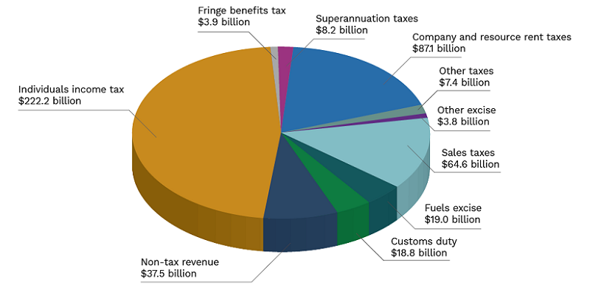

Where money is spent (2020-21)
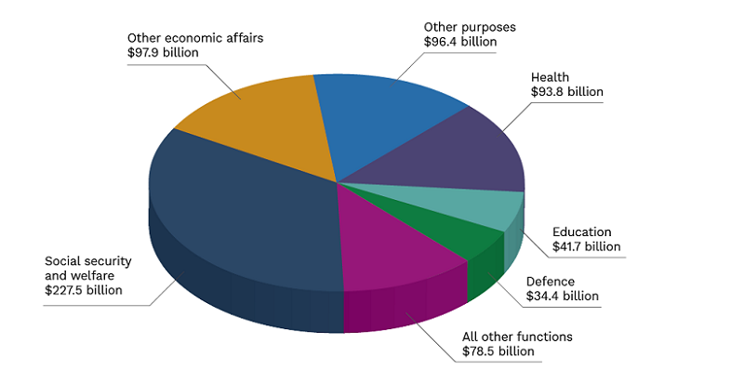
Source: 2020-21 Federal Budget Appendix B: Revenue and spending

